**T-725A**

**User Manual**

Before operating the Monitor, please read this manual thoroughly

and retain it for future reference.

**Key Description**

1: After pressing “MENU” to enter the menu screen, press this key to increase the setting value;

2:“MENU” : Short press to open the menu screen, return to the previous menu function setting / Toggle menu function/exit menu function setting;

3: After pressing "MENU" to enter the menu screen, press this key to decrease the setting value;

4 : Power button,；

5: CAM- CH1/CH2/CH3 Switch

6: Un-mirrored/Mirror Image Switch

7: Mode-user personality image mode button, like USER/DAY/NIGHT1/NIGHT2/NIGHT3.

8. IR Remote Window

**Remote control instructions**

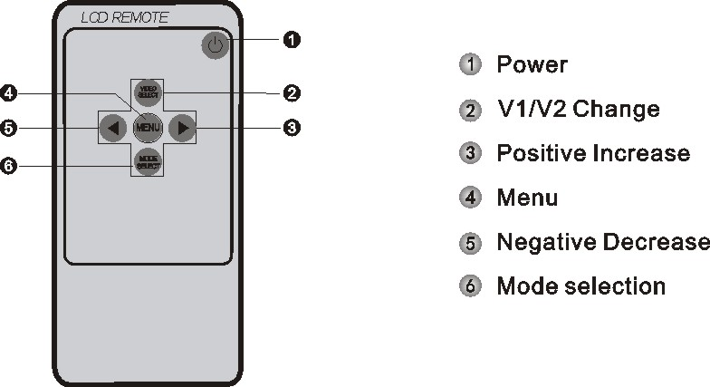

1. POWER：Turn on / off the screen picture output display;
2. VIDEO SELECT：Select between CH1/CH2/CH3；
3. Increase setting value;
4. Enter the menu screen and return to the previous menu function setting / exit menu function setting/exit menu function setting;
5. Decrease the setting value;

6: Color mode adjustment, you can choose USER/DAY/NIGHT1/NIGHT2/NIGHT3.

**Specifications**

|  |  |  |
| --- | --- | --- |
| **Item** | | **parameter** |
| LCD Dimension | | 7’’ |
| System language | | Chinese, English, Other (can be customized) |
| Video | Video input | 3 CH Video Inputs. 720P@25/30,1080P @25/30 or CVBS  PAL& NTSC Auto Recognize |
| Resolution | 1024*600 (IPS Panel) |
| Power and power consumption | Power management | Adaptive wide-format power input with protection functions such as low voltage, over voltage, and reverse short circuit; |
| Input voltage | DC: +12V ~ +36V |
| Output voltage | +12V |
| Power consumption | Normal working status <5W (without display and camera) |
| Working environment | Temperature | -30℃ ~ +70℃ |
| Humidity | 20% ~ 80% |

**Functions Description**

1. Press the MENU button to enter the **IMAGE SETTING**.

Using button 5 or button 7 to choose "BRIGHTNESS” or “CONTRAST” or “SATURATION” or “RESET” settings, use button 1 or button 3 to set the value. Use button 1 or button 3 to restore default settings;

1. Press the MENU button to enter the **GENERAL SETTING**.

Using button 5 or button 7 to choose CH1/CH2/CH3’s "GUIDES” settings, use button 1 or 3 to turn on and off it. After trigger wire is activated, the parking lines will be turned on or off.

Using button 5 or button 7 to choose CH1/CH2/CH3’s "DELAY” settings, use button 1 or 3 to turn on (1-15 seconds settable) or off it. After correspond trigger wire is activated, the triggered displayed image will keep showing for the set period (1-15 seconds) before switching to the default image.

3. Press the MENU button to enter the **SYS SETTING**.

Using button 5 or button 7 to choose the languages settings— English, Russian,Japanese,Korean.

Using button 5 or button 7 to choose the UPSIDE DOWN setting, use button 1 or button 3 to turn on or off it. If turn it on, you can install the monitor’s U bracket to the ceiling of your vehicle.

Using button 5 or button 7 to choose MIRROR setting, use button 1 or button 3 to turn on or off the mirrored or un-mirrored function.

Wiring Diagram

