**AHD REAR OBSERVATION**/ **BACKUP**

**CAMERA SYSTEM**

**OPERATION AND INSTALLATION MANUAL**

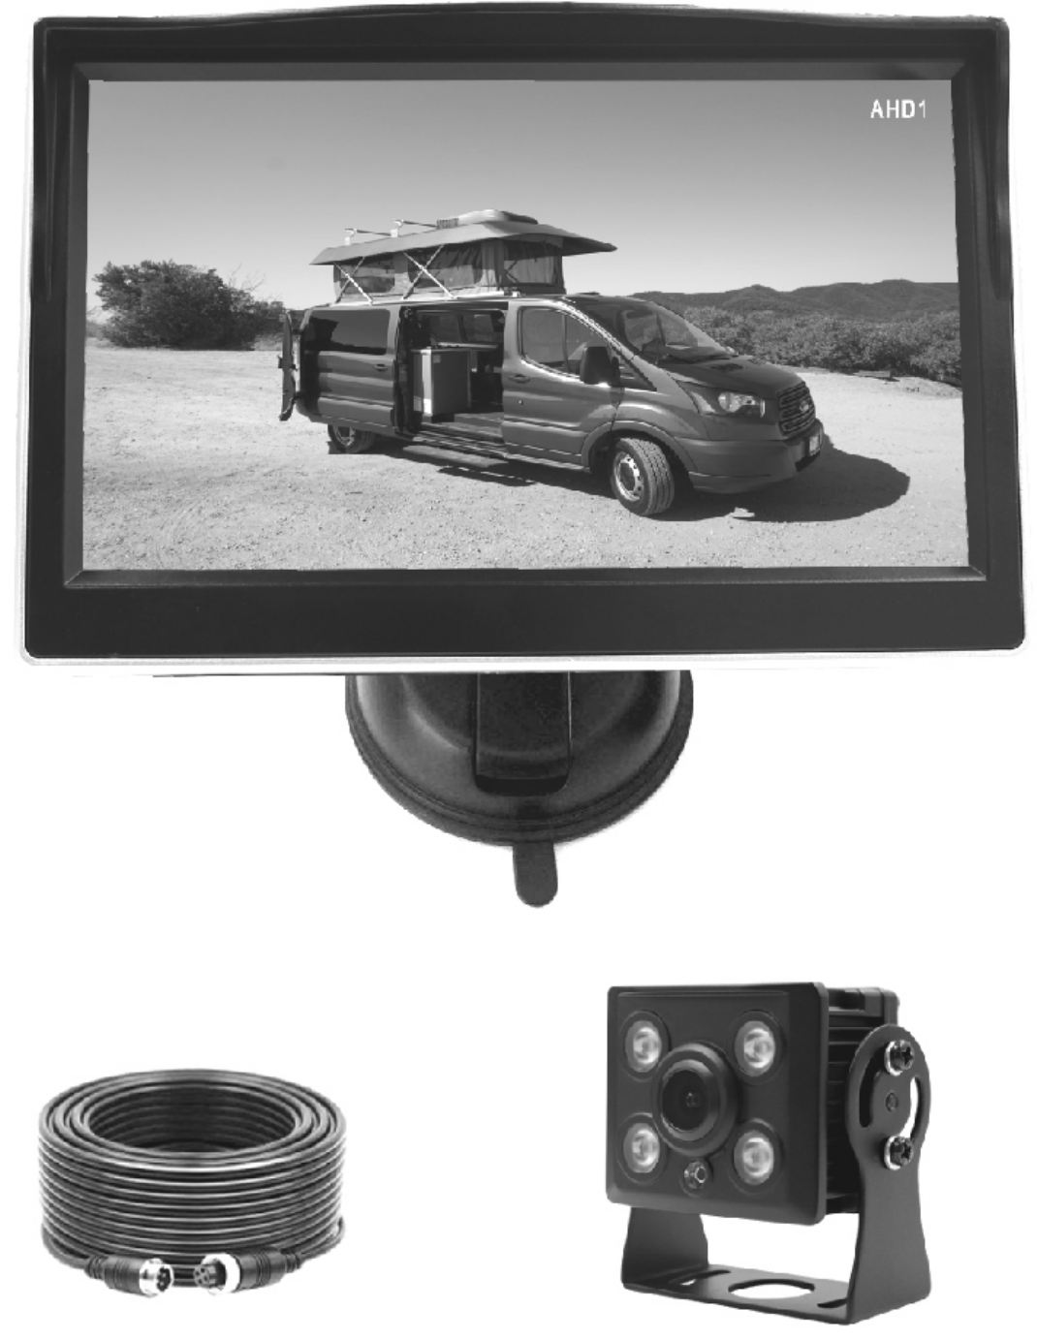

**INTRODUCTION**

Thank you for purchasing our product , please read it thoroughly before operating and keep it for future reference .

The AHD Rear Vision System will improve your ability to see behind your car , pickup truck , camper , travel trailer , fifth wheel trailer or motorhome . We have taken numerous measures

to ensure that your product is delivered in top condition and will perform to your satisfaction .

**IMPORTANT** **SAFETY** **INSTRUCTIONS**

**Before** **you** **install**

If you are not confident working with 12V/24V DC vehicle wiring , contact your vehicle manufacturer or your nearest retailer/installer to get a professional installation .

**Repair**

The camera system should not be opened. Any attempt at modification or repair by the user will void the warranty.

**PARTS**

1. Monitor 2. Camera

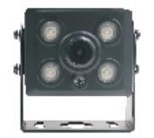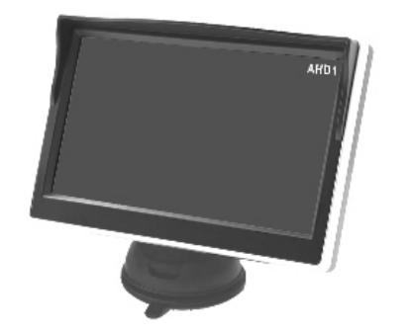

3.49 .2 ft Video Cable

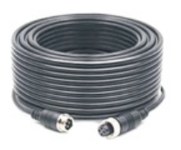

4.Accessories

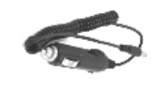

cigarette lighter

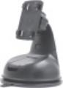

Suction cup mount

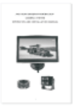

User Manual

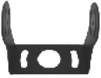

Camera bracket

|  |  |
| --- | --- |
|  |  |
| Screws & Bolt | |

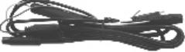

Power Cord

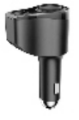

2 In 1 Cigarette Lighter Socket

**Attention:** The above accessories list may have little differences for different retail platforms ,

we may increase or update some accessories without notifying in advance , please subject to the actual received package .

**These instructions do not apply to all vehicles** . **They are only meant as a general**

**guide due to the number of different makes and models** . **For vehicle specific questions** , **contact your vehicle manufacturer.**

**Installation**

**Camera** **Installation** **Caution**

**Make sure there are no electrical cables** , **gas lines or important parts behind where the drill holes will be . Make sure to isolate the 12V or 24V power source by disconnecting the negative** (-) **terminal from the battery.**

**Metal brackets for plain surfaces**

screw TA4x8





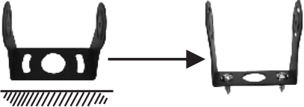

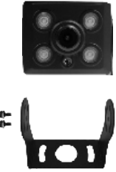

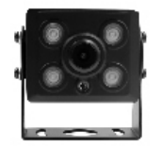Allen Screw 3x6

Washer ￠4





**Camera** **Positioning**

Camera location

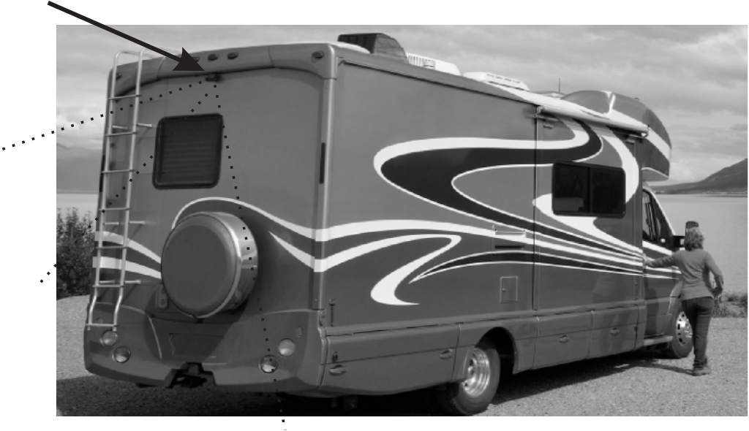

**Wiring** **Installation**

The system can be used as a rear observation system or as a backup camera system .

·To use it as a rear observation system , you can connect the camera with either CH1 or CH2 and no need to connect the trigger wire; To use the system as a backup camera system , the camera

needs to be connected with CH2 and the trigger wire should be connected with the reversing light's 12V.

1 .Choose routing path for the camera 's power cable to the power source depending on the desired

function .

2 .Before drilling the hole ,make sure there are no components behind the surface you are drilling such as electrical cables ,gas lines ,or other important components that can be damaged.

3 .After drilling the hole ,insert the supplied grommet then route the camera cable into the opening. The grommet must be used to prevent the metal edge from cutting the cable .

4 .Locate the power source required :Backup lights if used as a backup camera or running/marker lights is used as a rear/front observation system .

5.Once you have located the power source ,route the camera cable to that location . Never route the cable on the outside of the vehicle .

6 .Connect wires as diagram below.

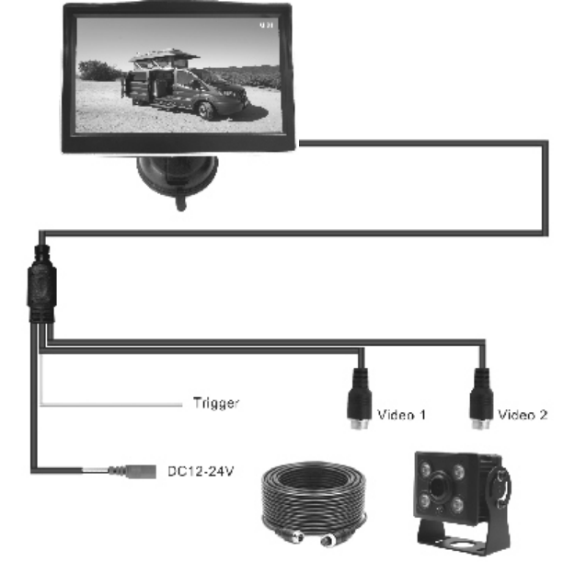

**Monitor** **Installation**

Make sure the monitor is mounted in a location that will not obstruct your vision while driving.

**1.On-dash Mounting 2.Suction cup Mounting**

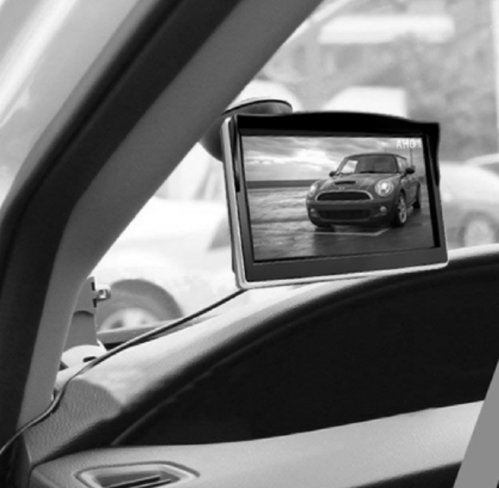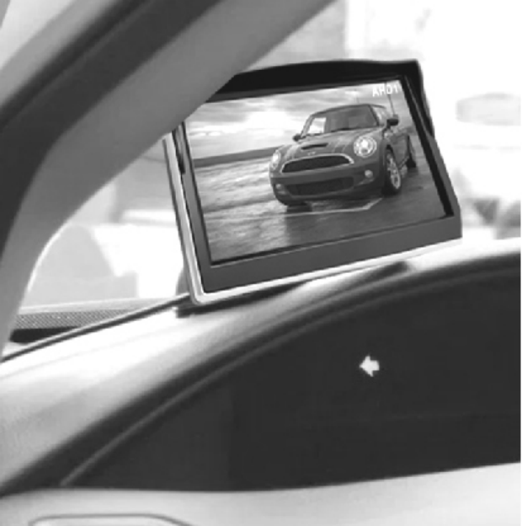

**Attention:** The trigger signal wire require professional techinical person to install , if you use it as rear observation system , please ignore it.

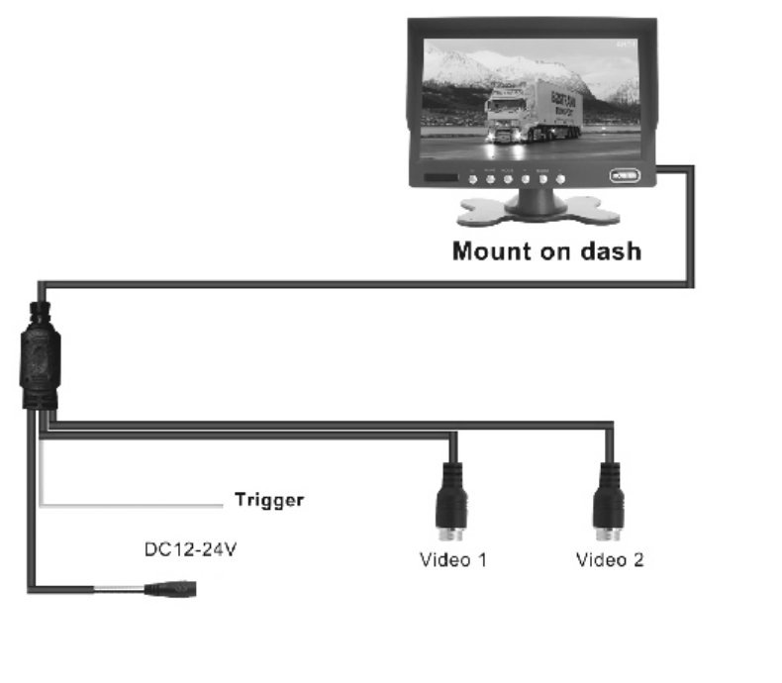

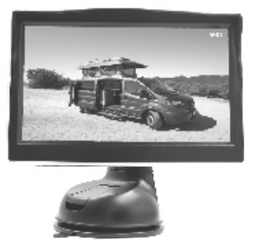

Reversing Trigger Wire

cigarette lighter

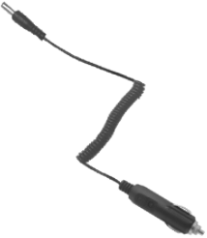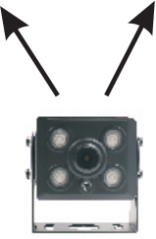

When the green wire is activated , the monitor automatically switches to Video 2 .

**OPERATION**

**1**. **Power** **Supply**

Power to the monitor is supplied with the vehicle's 12V/24V power socket.

**2**. **Monitor** **Operation**

The buttons include -,Menu ,+ ,as shown below :

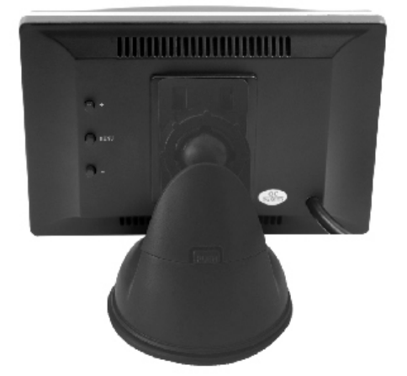 +  MENU  

|  |  |
| --- | --- |
| + | Select between AV1&AV2 Increase the settings value . |
| MENU | Short press to enter the OSD menu , long press to turn on or off the display. |
| - | Decrease the settings value . |

Press the MENU button to enter in main menu ,Short press the MENU button to select

Brightness / Contrast / Color / Languge / Default Setting/ RLUD/ Ruler Setting /Version

**1. BRIGHTNESS**

Press the “ + ” or “ - ” button to adjust the screen brightness .

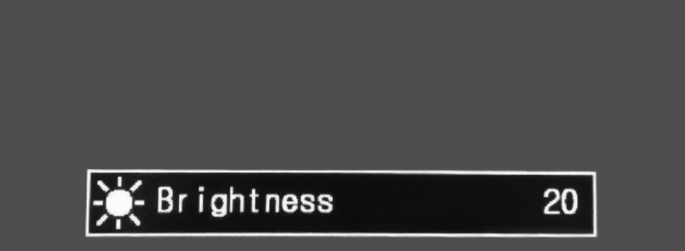

**2.CONTRAST**

Press the " +" or "-" button to adjust the contrast.

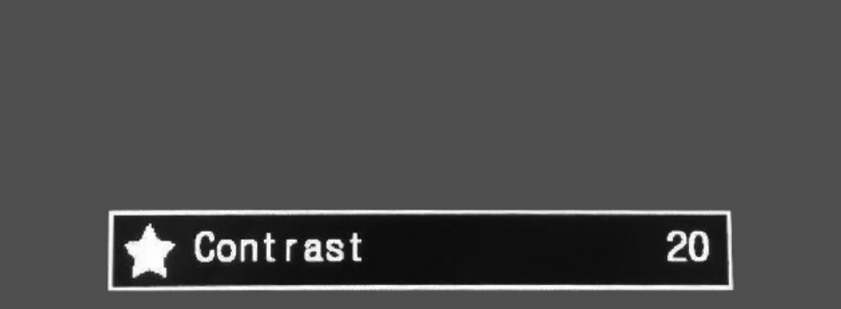

**3.COLOR**

Press the " +" or "-" button to adjust the color

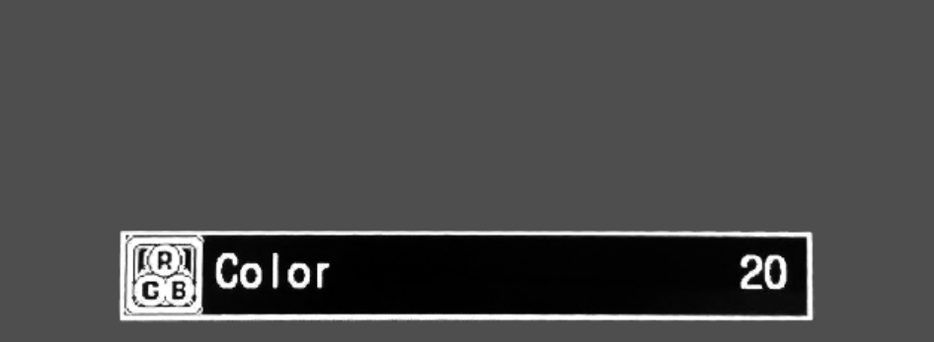

**4. LANGUAGE**

English only



**5.DEFAULT SETTING**

Press the " +" or "-" button to adjust the Default Setting

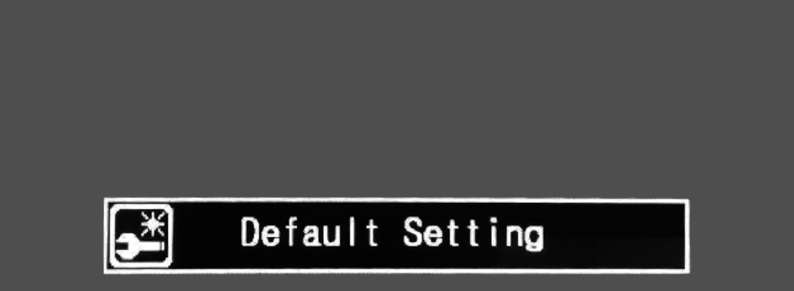

**6. UN-MIRRORED IMAGE**

Press the " +" or "-" button to set the mirror (backup camera) or un-mirrored image (front camera)

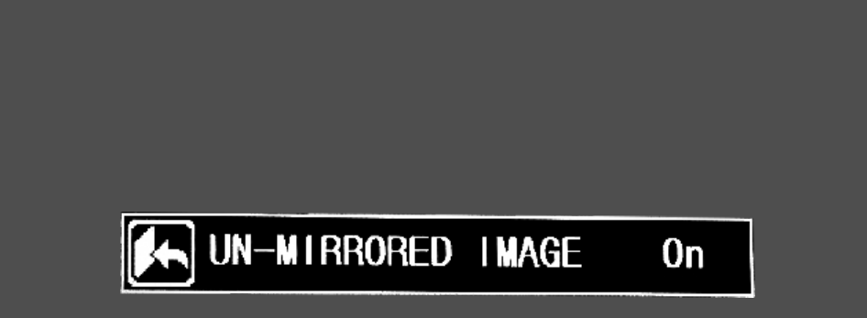

**6.RULER SETTING**

Press the " +" or "-" button to SET the Rear Assit Marker Lines on or off on CH1 or CH2 .

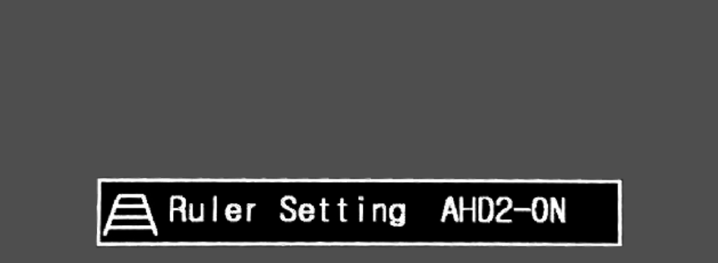

**4.VERSION**

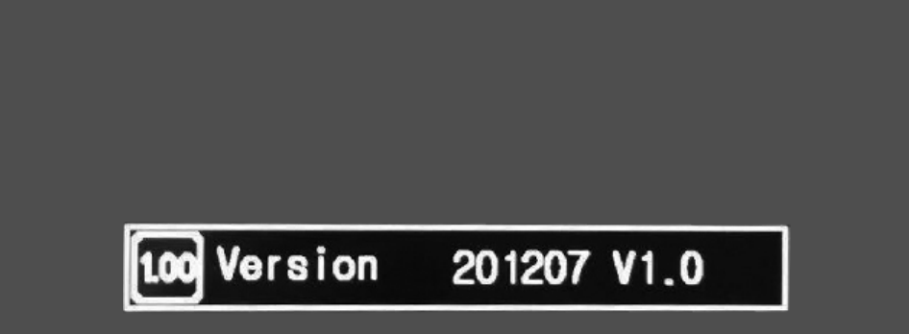

**TECHNICAL** **SPECIFICATIONS**

|  |  |
| --- | --- |
| **Camera** |  |
| Image Sensor | 1/3 Color CMOS |
| Waterproof Rate | IP69K |
| Power Supply | +12V |
| Current Consumption | TYPE:170mA , Max .250mA |
| Resolution | 2 .0 Mega 1080P |
| Frame Rate | 25f/s 30f/s |
| Operating Temperature | -30~ +70 ºC |
| Humidity | 20% ~ 80% |
|  |  |
|  |  |
| **LCD monitor** |  |
| LCD display screen size | 5 inch ( IPS Panel) |
| Resolution | 800*480 |
| Power Supply | +12~ +24V |
| Output Voltage | 12V |
| Current Consumption | TYPE:380mA , Max .480mA |
| Video input | 720P/ 1080P |
| Power consumption | Normal working status <5W |
| Operating Temperature | -30~ +70 ºC |
| Humidity | 20% ~ 80% |

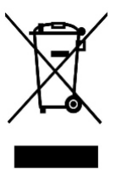

Waste electrical products should not be disposed of with household waste .

Please recycle where facilities exist. Check with

your local authority or retailer for recycling advice .