**T-M1025AQ**

**Instruction manual**

**银色的电视

**

Before operating the Monitor,please read this manual thoroughly and retain it for future reference.

**1.Key Description**

1: Power button

2: Decreasing the setting value

3:“MENU”:Short press to open the OSD menu,return to the previous menu function setting / Toggle menu function/exit menu function setting

4 : Increasing the setting value

5: CAM- CH1/CH2/CH3/CH4/2 or 3 Split View/Quad View Switch

6: Single full screen channel (CH1/CH2/CH3/CH4) switch/Navigation down

7: 2 or 3 Split view switch/Navigation up

8.Quad view switch

9.R/C Window

**2.Specifications**

|  |  |  |
| --- | --- | --- |
| **project** | | **parameter** |
| LCD Dimension | | 10’’ |
| System language | | English , Simplified Chinese, other (can be customized) |
| Video | Video input | 4 channels of 1080P, 960P, 720P, 960H, D1 (CVBS) video inputs;  Compatible with CVBS and AHD signal hybrid inputs;  Compatible with PAL and NTSC mixed input; |
| Resolution | 1024*600 |
| Display | Display | Full screen/2 or 3 Split/Quad View |
| Power and power consumption | Power management | Adaptive wide-format power input with protection functions such as low voltage, over voltage, and reverse short circuit; |
| Input voltage | |  | | --- | | DC: +12V ~ +3 DC+12V-36V | |
| Output voltage | +12V |
| Power consumption | Normal working status <5W (without display and camera) |
| Working environment | Temperature | -30℃ ~ +70℃ |
| Humidity | 20% ~ 80% |

**3.Function description**

Press the “MENU” button to enter the OSD function setting menu.

3.1.Picture

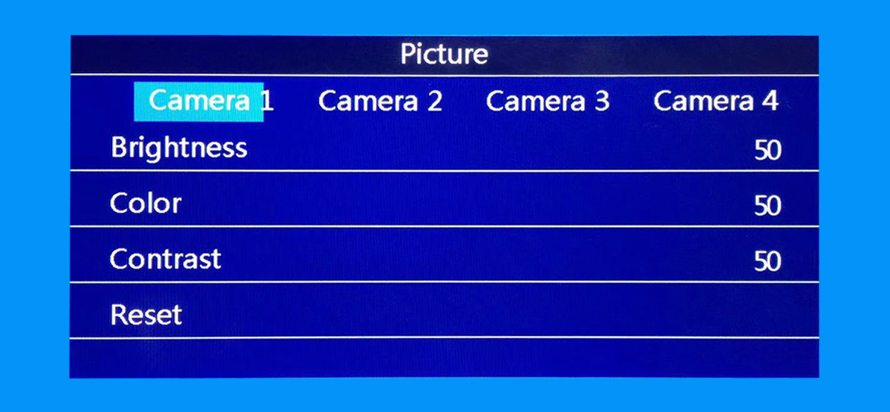

Using button 2 or 4 to enter the picture setting and select corresponded setting channels. Using button 6 or button 7 to select the brightness/color/contrast settings.(Please note that it will only effect when there is camera input)

1. Brightness:press button 6 or 7 to adjust the brightness value;
2. Color:press button 6 or 7 to adjust the color value;
3. Contrast:Press button 6 or 7 to adjust the contrast value;
4. Reset: using button 2 or 4 to restore the initial value;

3.2.Volume

Using button 2 or 4 to increase or decrease volume. (our monitor don’t have built-in speaker, it is an optional function)

3.3.Rotate

Using button 2 or button 4 to select the displayed image orientation between the default 01, 02, 03 and 04 settings.

01-Mirrored Image

02-Upside down Un-mirrored Image

03-Upside down Mirrored Image

04-Un-Mirrored Image (Remark:reverse camera’s image is mirrored image)

3.4.Blue Screen

Press button 2 or 4 to set the blue background on or off when there is no video input.

3.5.Auto Cycle

The screen will auto switch between CH1, CH2, CH3 and CH4 every 3 seconds

3.6.Languages

System languages — English, Franciso,Italian,Russian,Japanese,Korean,Germany,Deutch,Turkish,Arabic, Portuguese

3.7.ACC Delay

Use button 6 or button 7 to select the channels and use button 2 and button 4 to adjust the delay time from 0-20 seconds.

3.8.Guide Line

Use button 6 or button 7 to select the channels and use button 2 and button 4 to turn or off the guide line.(Remark:this feature will only effect when the trigger wires are activated)

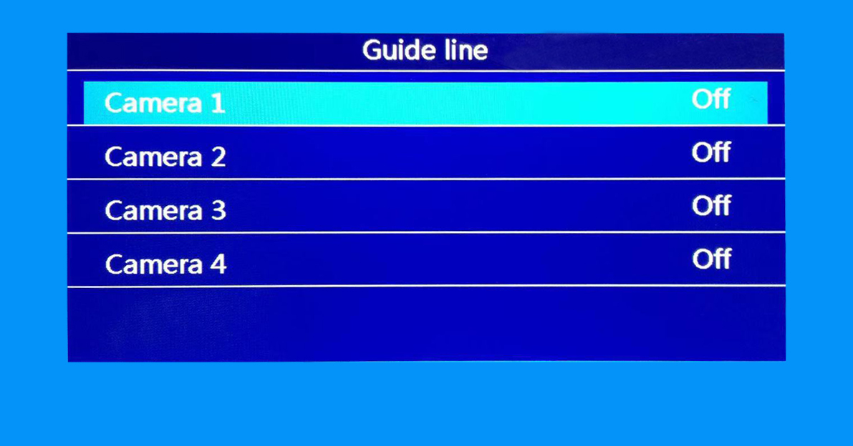

3.9 Video Rotate

Set each channel’s displayed image to up or down, mirror or un-mirrored

RU (means mirrored image),LU (means un-mirroed image),RD(means mirrored and upside down image),LD(means un-mirrored and upside down image).

3.10.Default Setting

Use button 2 or button 4 to reset the settings to factory default settings.

3.11.Version

System software version number

**4.Wiring Diagram**

**手机屏幕截图

**